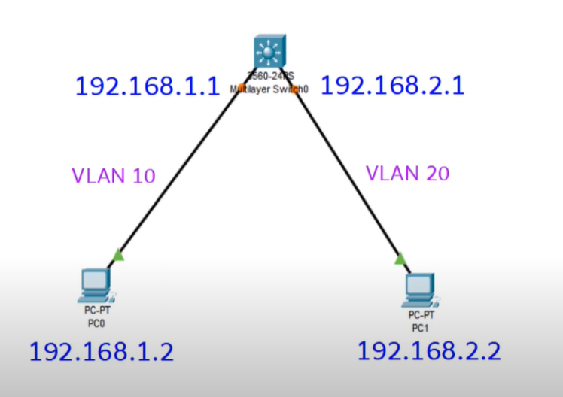

Switch>enable

Switch#configure terminal

Switch(config)#vlan 10

Switch(config-vlan)#name smile

Switch(config-vlan)#exit

Switch(config)#vlan 20

Switch(config-vlan)#name cisco

Switch(config-vlan)#exit

Interface fastEthernet 0/1

Switchport mode access

Switch port access vlan 10

Interface fastEthernet 0/2

Switchport mode access

Switch port access vlan 20

Switch(config)#

Switch(config)#interface vlan 10

Switch(config-if)#

Switch(config-if)#ip address 192.168.1.1 255.255.255.0

Switch(config-if)#no shutdown

Switch(config-if)#exit

Switch(config)#

Switch(config)#interface vlan 20

Switch(config-if)#

Switch(config-if)#ip address 192.168.2.1 255.255.255.0

Switch(config-if)#no shutdown

Switch(config-if)#exit

Switch(config)#exit

Configure terminal

Switch#show ip interface brief

Switch(config)#ip routing